HVAC CONTROLS INSTALLATION PROPOSAL
November 25, 2025
To: | Interested Bidders
Project: | Template
References: | Job Walk

PRICING SUMMARY
DESCRIPTION | Total Price
Base Bid | US $
Bond (if Required) | US $

FOR THE FOLLOWING SCOPE:
- Provide and install all raceways and wiring required for installation
- Install field devices per drawings (devices provided by others)
- Valves, temp well and PT ports installed by others

Base Proposal:

(Qty) | System Name

(1) | Network Controller
 |  | Installation of supervisory network controller panel
 |  | Does not include 120v for panels or control devices
 |  | Does not include network data drop for supervisory devices

(1) | Chilled Water System
 |  | Install Field Controller and panel (provided by others)
 |  | Provide and install all raceways and wiring required for installation
 |  | Install field devices per drawings (devices provided by others)

(1) | Hot Water System
 |  | Install Field Controller and panel (provided by others)
 |  | Provide and install all raceways and wiring required for installation
 |  | Install field devices per drawings (devices provided by others)

(1) | Air Handling Unit
 |  | Install Field Controller and panel (provided by others)
 |  | Provide and install all raceways and wiring required for installation
 |  | Install field devices per drawings (devices provided by others)

(1) | Variable Air Volume Terminal Unit
 |  | Install Field Controller (provided by others)
 |  | Provide and install all raceways and wiring required for installation
 |  | Install field devices per drawings (devices provided by others)

(1) | DX Split System
 |  | Install Field Controller and panel (provided by others)
 |  | Provide and install all raceways and wiring required for installation
 |  | Install field devices per drawings (devices provided by others)

(1) | Ductless Split System
 |  | Install Manufacturer Thermostat (provided by others)
 |  | Install EMCS space temp sensor (if required)
 |  | Provide and install all raceways and wiring required for installation
 |  | Install BACnet communication bus to DSS (if required)
 |  | Install field devices per drawings (devices provided by others)

(1) | Exhaust Fan Interlock
 |  | Provide and install all raceways and wiring required for installation
 |  | Install field devices per drawings (devices provided by others)
- Start/Stop Relay
- Fan Status switch

(1) | E-Stop Panel
 |  | Install E-Stop button (provided by others)
 |  | Provide and install all raceways and wiring required for installation
 |  | Install field devices per drawings (devices provided by others)

(1) | Electrical Metering Package
 |  | Install Field Controller (mount and address) (provided by others)
 |  | Provide and install all raceways and wiring required for installation
 |  | Install field devices per drawings (devices provided by others)
WARRANTY
- Includes warranty for (1) year from date of owner’s acceptance of a certificate of substantial completion.

CLARIFICATIONS:
- This proposal shall be incorporated into any final contract terms and conditions.
- Pricing is based on normal working hours (Monday through Friday). No overtime labor is included in the pricing above.
  - If an accurate construction schedule is provided at contract execution, The Controls Company (TCC) will absorb any required overtime to meet contractual milestones.
  - If no accurate schedule is provided, overtime will be billed at 1.5× the burdened labor rate and shall be executed only with an approved change order.
- All concealed but accessible wiring shall be installed using plenum-rated cable, following proper installation techniques in a neat and workmanlike manner.
- All exposed or inaccessible wiring shall be installed in EMT conduit.
- Communication wiring between units may be installed using metallic-armored cable (MC) where permitted by the project specifications.
- The Controls Company reserves the right to withdraw or revise this proposal in the event of a substantial change in scope.
- Any devices provided by others (e.g., sensors, actuators) must be delivered to the site and ready for installation.
  - TCC is not responsible for delays caused by missing, incompatible, or non-functional equipment, and reserves the right to issue a change order for additional labor or material required.

EXCLUSIONS:
- Furnishing of any control damper unless noted in the scope above.
- Furnishing of any electric meter, water meter and gas meter.
- Furnishing, installation, and wiring of VFDs, except control signal and communication.
- Furnishing, installation and wiring of smoke detectors, smoke dampers, combination fire/smoke dampers, and fire dampers and associated actuators and wiring unless noted in the scope above.
- Installation of dampers, Airflow measuring stations, valves, immersion wells, pressure taps or flow meters as listed in the above scope of work.
- After-hour, weekend or holiday work
- Any 120V wiring.
- Network data drops and wiring unless noted in the scope above.
- Does not include BIM modeling
- Does not include demolition unless noted in the scope above.

This Proposal is Valid Until for 30 days from the proposed date.

Purchaser - Company Name |  | The Controls Company, LLC.
 |  | 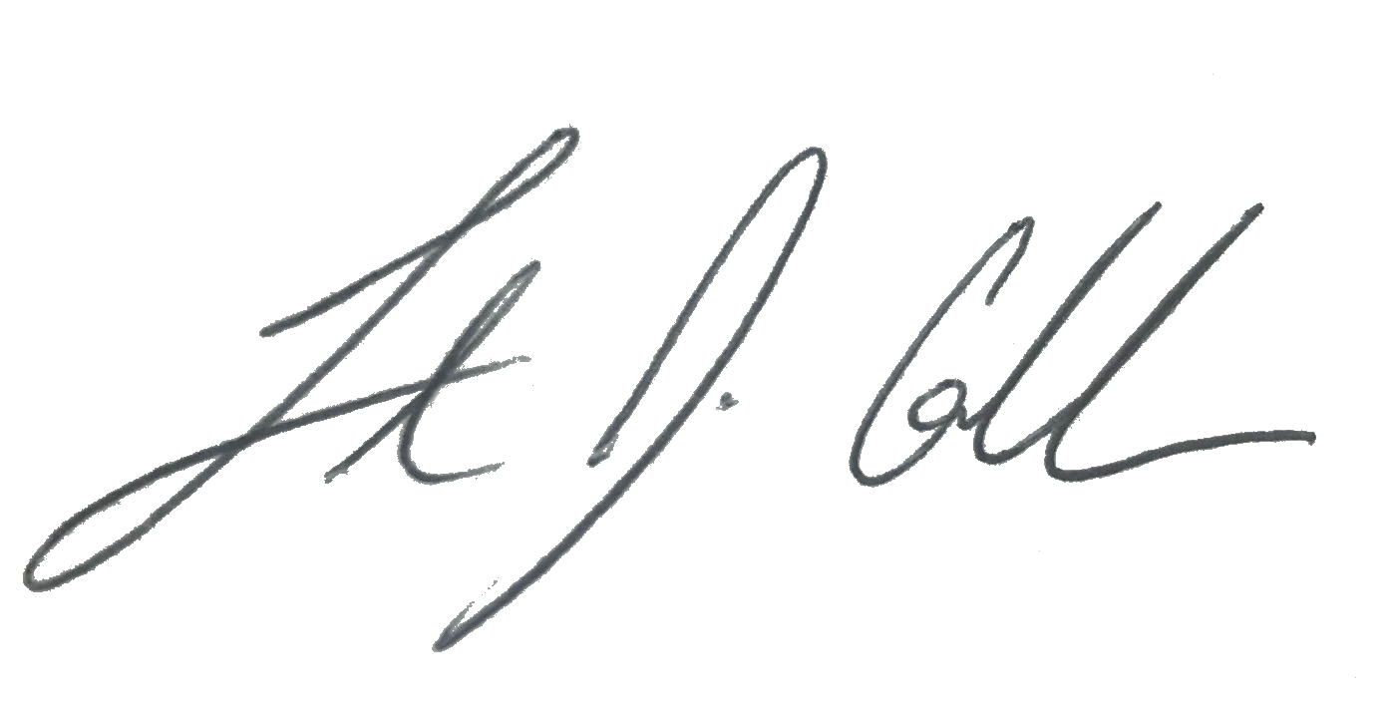
Signature |  | Signature
Name: |  | Name: Timothy J. Collins
Title: |  | Title: President
Date: |  | Date: November 25, 2025

